**Calculating Family Expenses using Service Now**

**Team ID: NM2025TMID18302**

|  |  |  |
| --- | --- | --- |
| Name | NM ID | Position |
| DEVA KRISHNA.K | **F4D8B84822F1A2E8E184964CAB33F23A** | **Leader** |
| DINESH N | **944D02051FB725AB9C54FA55DC7C8A8B** | **Member** |
| HEMCHAND A | **F1B32793815B45C93E74FC19AE0AB358** | **Member** |
| SOVIYAN M | **87C6DC6370C31D69A42435729E82514D** | **Member** |

**TABLE OF CONTENTS**

|  |  |  |
| --- | --- | --- |
| CHAPTER NO. | TITLE | PAGE NO. |
| - | **ABSTRACT** | **4** |
| 1 | **Introdution** | **5** |
|  | 1.1 Current Issues | **5** |
| 1.2 Service Now | **6** |
| 1.3 Uses of Service now in Family Expenses | **7** |
| 2 | **Develeoping the Family Expense Calculation System in Servicenow Developer Instance** | **8** |
|  | 2.1. Setting up ServiceNow Instance | **8** |
| 2.2. Creation of New Update Set | **8** |
| 2.3. Creation of New Update Set | **9** |
| 2.4. Creation of Table(Daily Expenses) | **10** |
| 2.5. Creation of Family Expenses Table | **13** |
| 2.6. Creation of Relationship between Family Expenses and Daily Expenses tables | **16** |
| 2.7. Configuring Related List on Family Expenses | **16** |
| 2.8. Creation of Business Rules | **17** |
| 2.9. Configure the Relationship | **19** |
| 2.10. Conclusion | **19** |
| 3 | **Chapter : 3 – Purpose of Tables and Future Analysis** | **20** |
|  | 3.1 Family Expense Table | **20** |
| 3.2 Daily Expense Table | **21** |
| 3.3 Purpose of Creating These Tables | **21** |
| 3.4 Future Analysis with the Tables | **23** |
| 4 | **Chapter : 4 -- Real-World Applications of Family Expense Management** | **23** |
|  | 4.1 Tracking Monthly Household Expenses | **23** |
| 4.2 Identifying Highest Spending Family Member | **23** |
| 4.3 Category-wise Expense Analysis | **23** |
| 4.4 Budget vs. Actual Comparison | **24** |
| 4.5 Saving Opportunity Identification | **24** |
| 4.6 Predicting Future Expenses | **24** |
| 4.7 Emergency Expense Tracking | **25** |
| 4.8 Visual Reports and Dashboards | **25** |
| 5 | **Chapter : 5 -- Implementation with Problems and Visualization** | **26** |
|  | 5.1 Problems in Family Expenses Table | **27** |
| 5.2 Problems in Daily Expenses Table | **28** |
| 6 | **Conclusion** | **30** |

**Abstract**

The project titled **"Family Expense Management Using ServiceNow"** focuses on building a smart and structured application to manage household spending effectively by utilizing the capabilities of the **ServiceNow** platform. In today’s busy world, many families find it difficult to consistently monitor their financial activities, often resulting in unorganized expenses and potential budget issues.

To solve this problem, the proposed system introduces a centralized and easy-to-use solution where users can log their day-to-day expenses, assign them to defined categories (such as groceries, utility bills, education, health, and leisure), and analyze them efficiently. The system also enables users to set financial limits per category and monitor their actual expenses in real-time to avoid overspending.

This platform takes advantage of ServiceNow’s core features such as **workflow automation**, **data handling**, and **system integration** to ensure the application is reliable, scalable, and accurate. The solution is designed with simplicity in mind, allowing even users with limited technical experience to navigate and manage their data with ease.

Moreover, the system supports further enhancements like budget limit alerts, automatic monthly reports, and integration with other financial tools or platforms. By offering meaningful insights into financial behavior through charts and dashboards, this project helps families make better financial decisions, encourages responsible spending, and supports long-term budgeting goals and financial health.

**Chapter : 1 : Introduction**

Managing family expenses has become an essential aspect of modern life, as financial stability plays a critical role in ensuring the overall well-being of households. With the increasing number of daily expenditures and diverse financial commitments, families often find it challenging to monitor their spending effectively. Traditional methods, such as manual tracking or using spreadsheets, are time-consuming, error-prone, and lack real-time insights. This creates the need for a smarter, automated, and user-friendly solution that simplifies financial management.

The project *“Calculating Family Expenses using ServiceNow”* addresses this challenge by utilizing the powerful capabilities of the ServiceNow platform to develop an expense management system tailored for families. ServiceNow, known for its robust workflow automation, data handling, and integration features, provides a strong foundation for building scalable and efficient applications beyond its conventional IT service management use.

This system allows users to record and categorize expenses under various heads, set budgets for each category, and track them in real time. The platform further provides detailed reports and analytics, helping families identify spending patterns, control unnecessary expenditures, and make informed financial decisions. With a focus on user experience, the system is designed to be intuitive and accessible, ensuring that even users with minimal technical knowledge can operate it with ease.

By integrating advanced functionalities such as automated alerts for budget limits, monthly expenditure summaries, and data visualization, the project not only streamlines the expense management process but also encourages families to develop better financial discipline. Ultimately, this project contributes towards promoting financial awareness, transparency, and long-term financial well-being within the family unit.

* 1. **Current Issues:**

Managing family expenses manually or through basic digital tools comes with several challenges that often result in financial mismanagement. Some of the key issues identified are:

1. **Lack of Centralized Tracking**
   * Families usually depend on notebooks, spreadsheets, or different mobile apps for expense tracking, which leads to scattered and unorganized financial data.
2. **Difficulty in Categorization**
   * Expenses are not always properly classified under categories like food, utilities, healthcare, or education. This makes it hard to understand where the majority of money is being spent.
3. **Time-Consuming Process**
   * Manual entry and calculation of expenses require significant time and effort, often discouraging consistent tracking.
4. **Inaccurate Budget Monitoring**
   * Without automated tools, families may overshoot their budget unknowingly, since there is no real-time alert mechanism.
5. **Limited Analytical Insights**
   * Basic methods of tracking do not provide detailed insights, such as monthly trends, spending patterns, or comparative analysis across categories.
6. **Data Security and Reliability**
   * Using third-party tools or manual records may compromise financial data security and lack reliability for long-term record keeping.
7. **Scalability Issues**
   * As family size and expenses grow, traditional methods fail to scale, making it increasingly difficult to manage finances effectively.
   1. **Service Now:**

ServiceNow is a **cloud-based platform** that provides digital workflows to automate and streamline business processes across different industries. Originally developed for IT Service Management (ITSM), ServiceNow has now expanded into areas such as Human Resources, Customer Service, Security Operations, and custom application development.

The key strength of ServiceNow lies in its ability to:

* **Automate workflows** – Reduces manual work by handling routine and repetitive tasks automatically.
* **Centralize data** – Stores and manages information in a single system of record, improving accessibility and accuracy.
* **Support custom applications** – Allows developers and users to create applications tailored to specific needs without complex coding.
* **Provide reporting and dashboards** – Offers real-time insights into processes, trends, and performance metrics.
* **Ensure scalability and security** – Handles large-scale operations with strong data protection measures.

ServiceNow is widely used by organizations because it increases efficiency, enhances user experience, and reduces operational costs. In this project, ServiceNow is utilized beyond its traditional business uses, serving as a platform to build a **family expense management system** that helps users track, categorize, and analyze their financial activities in a simple and effective way.

* 1. **Uses of Service Now in Family Expenses:**

The selection of ServiceNow as the platform for developing the *“Calculating Family Expenses”* system brings several advantages, as it provides powerful tools for automation, integration, and scalability. The following are the key uses of ServiceNow in this project:

1. **Centralized Platform**
   * ServiceNow offers a single, unified platform where all family expense data can be stored, tracked, and managed efficiently.
2. **Workflow Automation**
   * Routine tasks such as recording expenses, categorizing them, and generating reports can be automated, reducing manual effort and improving accuracy.
3. **Real-Time Tracking**
   * ServiceNow enables real-time expense monitoring, ensuring that users are always aware of their financial status and budget utilization.
4. **Customization and Scalability**
   * The platform supports customization to adapt to different family sizes, expense categories, and financial complexities. It can easily scale as the family’s financial requirements grow.
5. **Reporting and Analytics**
   * ServiceNow provides built-in reporting and dashboard features that can generate monthly summaries, visualizations, and detailed insights into spending patterns.
6. **Integration Capabilities**
   * The system can be integrated with other financial tools, applications, or external data sources, further enhancing functionality.
7. **User-Friendly Interface**
   * ServiceNow’s intuitive design and form-based structure make it easy for non-technical users to enter and analyze expense data without difficulty.
8. **Data Security and Reliability**
   * ServiceNow ensures secure data storage with role-based access, protecting sensitive financial information from unauthorized use.

**Chapter : 2 :** Develeoping the Family Expense Calculation System in Servicenow Developer Instance

2.1. **Setting up ServiceNow Instance**

1. Sign up for a developer account on the ServiceNow Developer site “https://developer.servicenow.com”.
2. Once logged in, navigate to the "Personal Developer Instance" section.
3. Click on "Request Instance" to create a new ServiceNow instance.
4. Fill out the required information and submit the request.
5. You'll receive an email with the instance details once it's ready.
6. Log in to your ServiceNow instance using the provided credentials.
7. Now you will navigate to the ServiceNow.

2.2. **Creation of New Update Set**

1. Go to All >> In the filter search for Local Update set > click on New.

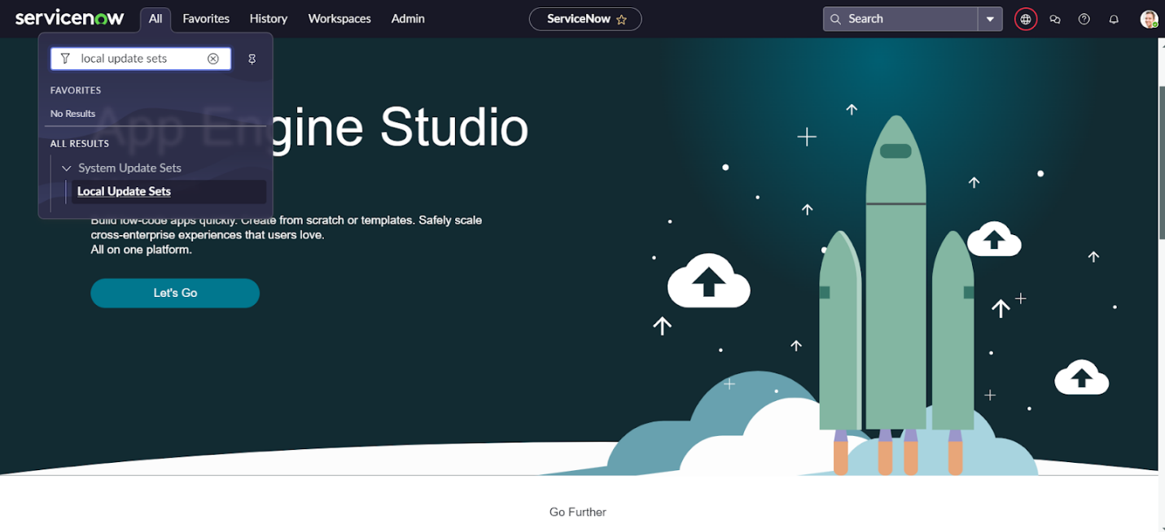

1. Enter the Details as:

Name : Family Expenses

1. 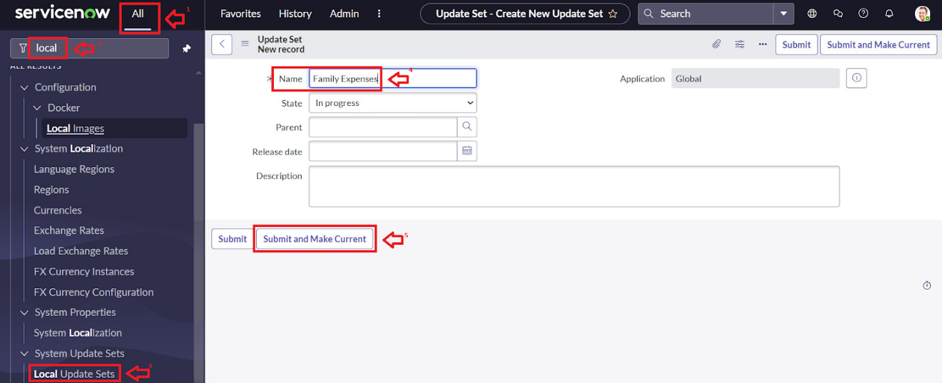Then click on Submit and Make current.

2.3. **Creation of New Update Set**

1. Go to All >> In the filter search for Local Update set > click on New.
2. Enter the Details as:

Name : Family Expenses

1. Then click on Submit and Make current.



2.4. **Creation of Table(Daily Expenses)**

2.4.1. **Creation of Daily Expenses Table**

1. Go to All > In the filter search for Tables > click on New.
2. Enter the Details:

Label : Daily Expenses

Name : Auto-Populated

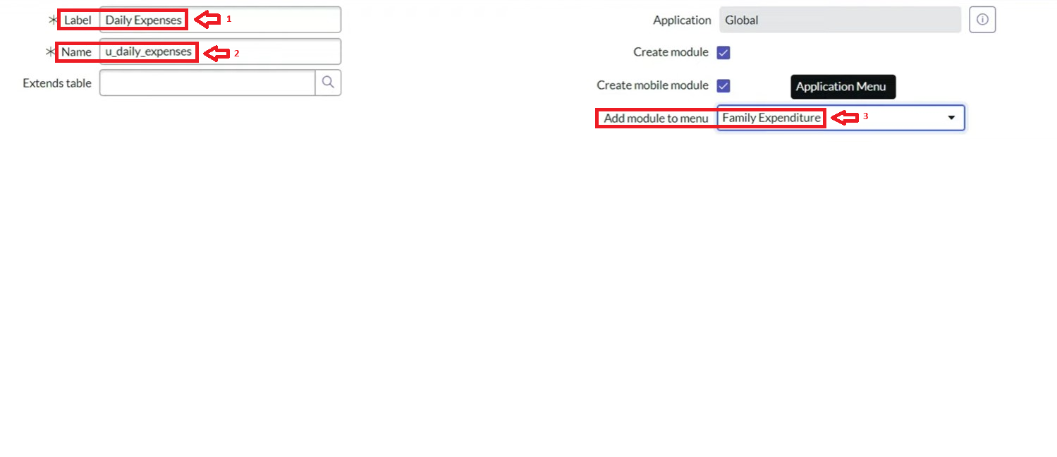Add Module to menu : Daily Expenditure

1. Go to the Header and right click there>> click on Save.

2.4.2. **Creation of Columns(Fields)**

1. Near Columns Double click near insert a new row.
2. Give the details as:

Column label : Number

Type : String

1. Double click on insert a new row again
2. Give the details as:

Column label : Date

Type : Date

1. Double click on insert a new row again
2. Give the details as:

Column label : Expense

Type : Integer

1. Double click on insert a new row again
2. Give the details as:

Column label : Family Member Name

Type : Reference

Max length : 800

1. Double click on insert a new row again
2. Give the details as:

Column label : Comments

Type : String

Max length : 800

11. Go to the Header and right click there>> click on Save.

2.4.3. **Making Number Field an Auto-Number**

* Double click on the Number Field/Column.
* Go down and double click on Advanced view
* In Default Value:

Use dynamic default : check the box

Dynamic default value : Get Next Padded Number

* 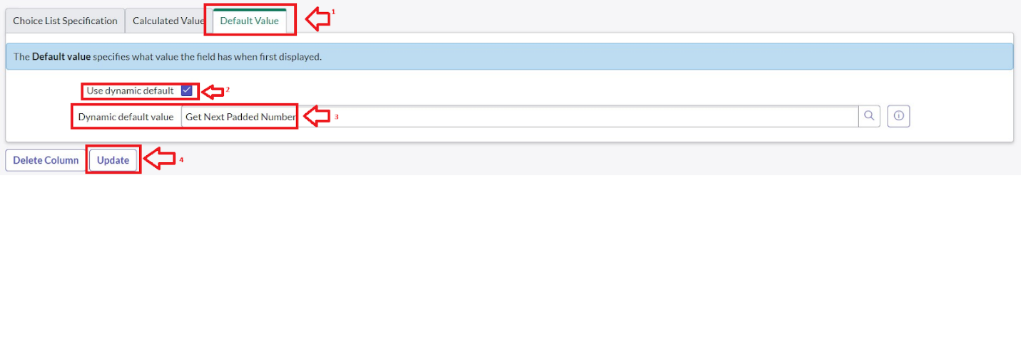Click on Update.
* Go to All >> In the filter search for Number Maintenance >> select Number Maintenance
* Click on New.
* Enter the below Details:

Table : Family Expenses

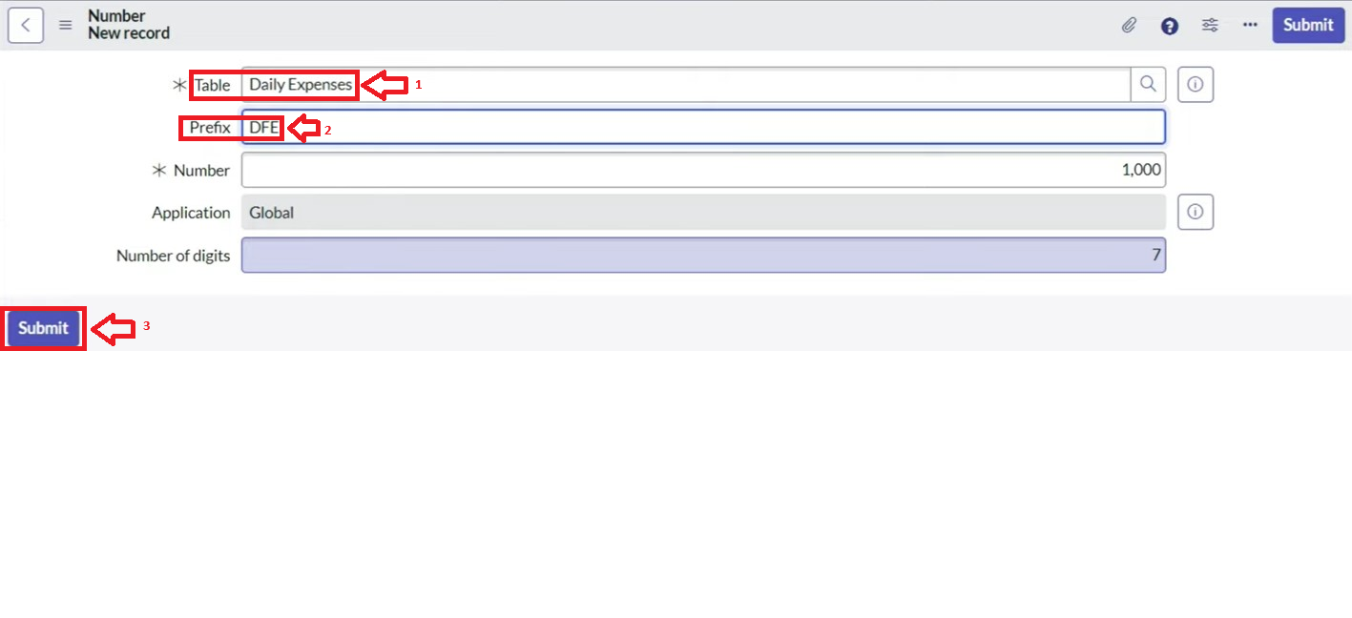Prefix : MFE

* Click on Submit.

2.4.4. **Configure the Form**

1. Go to All >> In the filter search for Daily Expenses >> Open Daily Expenses
2. Click on New
3. Go to the Header and right click there>> click on Configure >> Select Form Design
4. 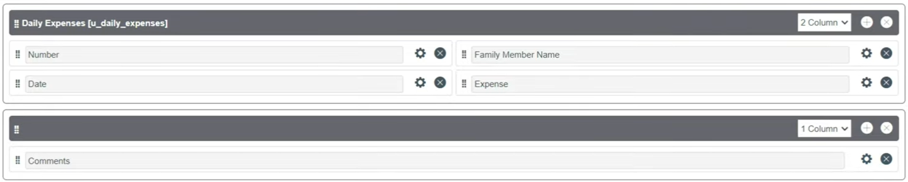Customize or Drag Drop the form as per your requirement.
5. Make Number Read-Only Field by clicking on the gear icon and checking Read-Only
6. Make Date, Family Member Name Mandatory Field by clicking on the gear icon and checking Mandatory
7. Click on Save.

2.5. **Creation of Family Expenses Table**

1. Go to All > In the filter search for Tables > click on New.
2. Enter the Details:

Label : Family Expenses

Name : Auto-Populated

New menu name : Family Expenditure

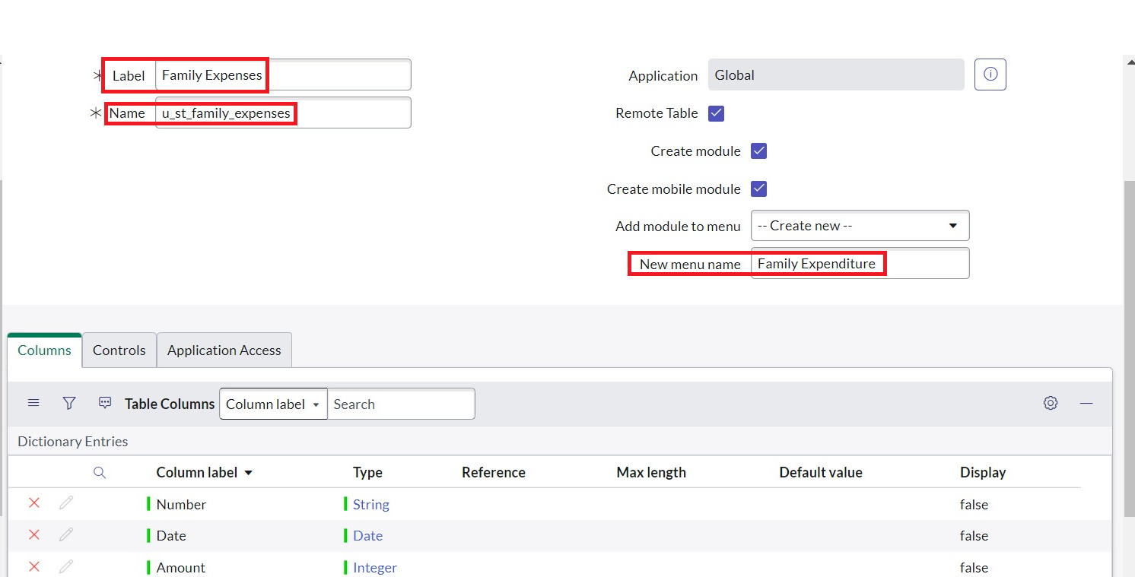

1. Go to the Header and right click there>> click on Save.

2.5.1. **Creation of Columns(Fields)**

1. Near Columns Double click near insert a new row.
2. Give the details as:

Column label : Number

Type : String

1. Double click on insert a new row again
2. Give the details as:

Column label : Date

Type : Date

1. Double click on insert a new row again
2. Give the details as:

Column label : Amount

Type : Integer

1. Double click on insert a new row again
2. Give the details as:

Column label : Expense Details

Type : String

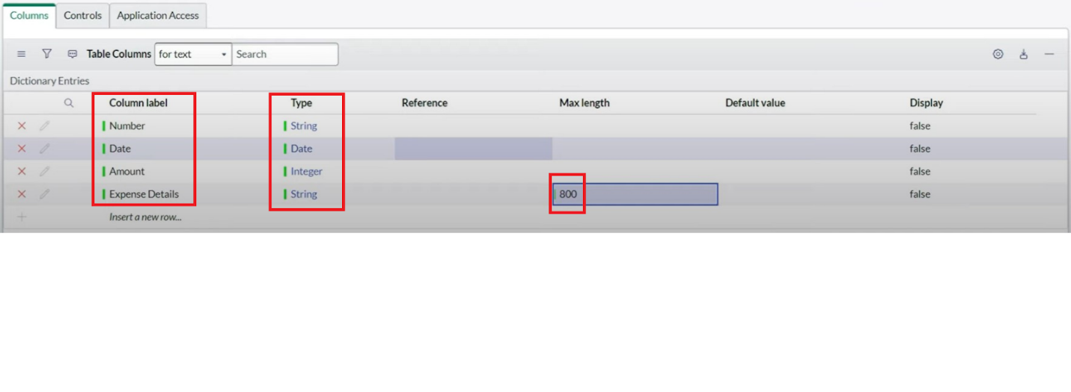Max length : 800

1. Go to the Header and right click there>> click on Save.

2.5.2. **Making Number Field an Auto-Number**

1. Double click on the Number Field/Column.
2. Go down and double click on Advanced view
3. In Default Value:

Use dynamic default : check the box

Dynamic default value : Get Next Padded Number

4. Click on Update.



Go to All >> In the filter search for Number Maintenance >> select Number Maintenance

Click on New.

Enter the below Details:

Table : Family Expenses

Prefix : MFE

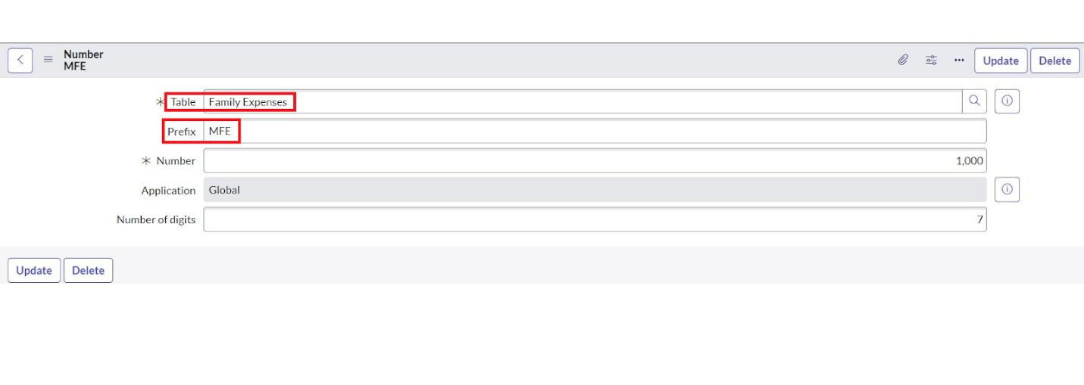

Click on Submit.

2.5.3. **Configure the Form**

1. Go to All >> In the filter search for Family Expenses >> Open Family Expenses
2. Click on New
3. Go to the Header and right click there>> click on Configure >> Select Form Design
4. 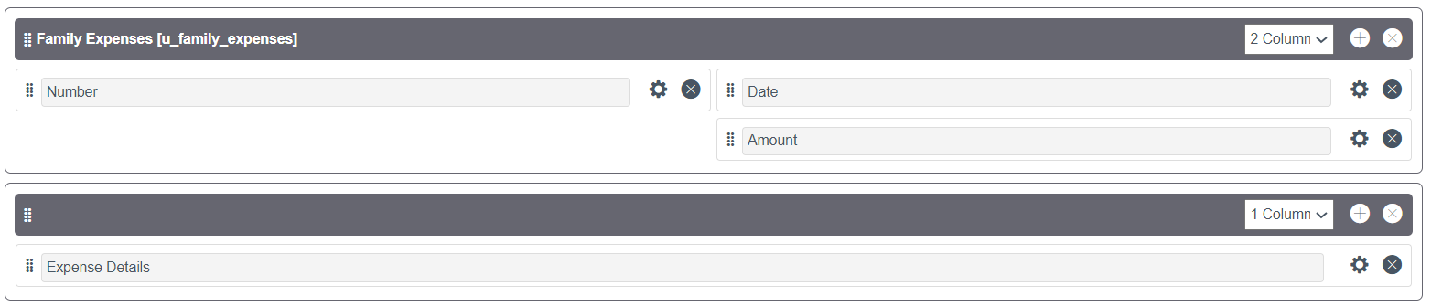Customize or Drag Drop the form as per your requirement.
5. Make Number Read-Only Field by clicking on the gear icon and checking Read-Only
6. Make Date, Amount Mandatory Field by clicking on the gear icon and checking Mandatory
7. Click on Save.

2.6. **Creation of Relationship between Family Expenses and Daily Expenses tables**

1. Go to All >> In the filter search for Relationships >> Open Relationships
2. Click on New.
3. Enter the details:

Name : Daily Expenses

Applies to table : Select Family Expenses

Daily Expenses : Select Daily Expenses

1. Click Save.

2.7. **Configuring Related List on Family Expenses**

1. Go to All >> In the filter search for Family Expenses >> Open Family Expenses
2. Click on New
3. Go to the Header and right click there>> click on Configure >> Select Related Lists
4. Add Daily Expenses to the Selected Area.
5. Click on Save

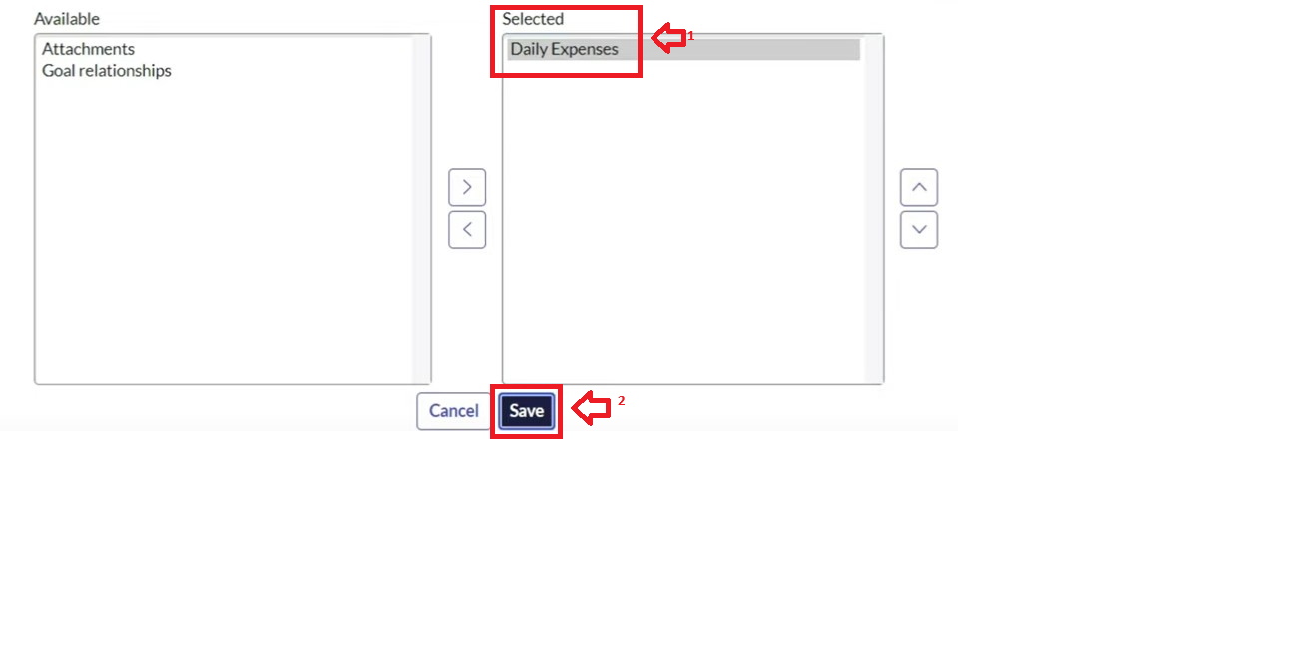

2.8. **Creation of Business Rules**

1. Go to All >> In the filter search for Business Rules.
2. Under System Definition Select Business Rules then click on New.
3. Enter the Details:

Name : Family Expenses BR

Table : Select Daily Expenses

Check Advanced

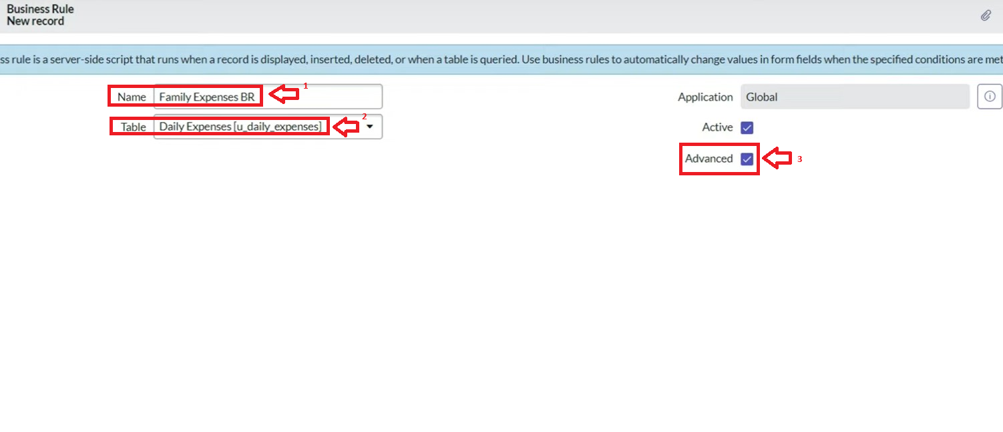

1. In when to run Check Insert and Update

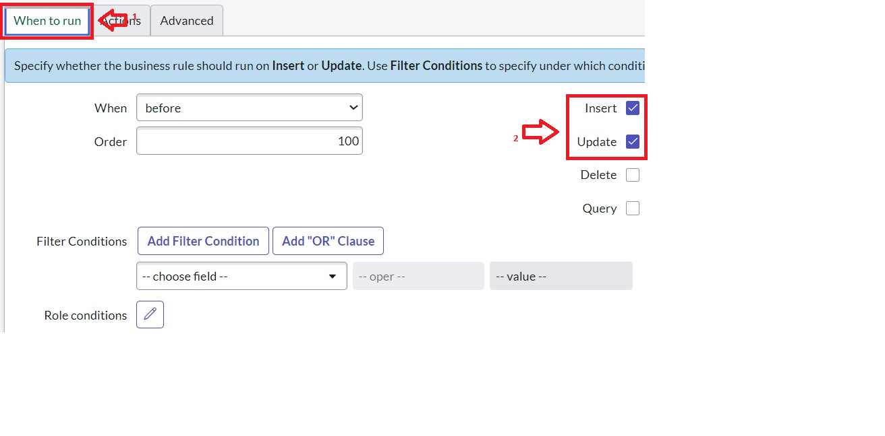

1. In Advance(we write the code): Write the below code >>

(function executeRule(current, previous /*null when async*/) {

var FamilyExpenses = new GlideRecord('u_family_expenses');

FamilyExpenses.addQuery('u_date',current.u_date);

FamilyExpenses.query();

if(FamilyExpenses.next())

{

FamilyExpenses.u_amount += current.u_expense;

FamilyExpenses.u_expense_details += ">"+current.u_comments+":"+"Rs."+current.u_expense+"/-";

FamilyExpenses.update();

}

else

{

var NewFamilyExpenses = new GlideRecord('u_family_expenses');

NewFamilyExpenses.u_date = current.u_date;

NewFamilyExpenses.u_amount = current.u_expense;

NewFamilyExpenses.u_expense_details += ">"+current.u_comments+":"+"Rs."+current.u_expense+"/-";

NewFamilyExpenses.insert();

}

})(current, previous);

1. Go to the Header and right click there>> click on Save.

2.9. **Configure the Relationship**

1. Go to All >> In the filter search for Relationships >> Open Relationships.
2. In that, open Daily Expenses Relationship.
3. For Applies to table : Select Family Expenses.
4. In Query with : write the below Query.

(function refineQuery(current, parent) {

// Add your code here, such as current.addQuery(field, value);

current.addQuery('u_date',parent.u_date);

current.query();

})(current, parent);

1. 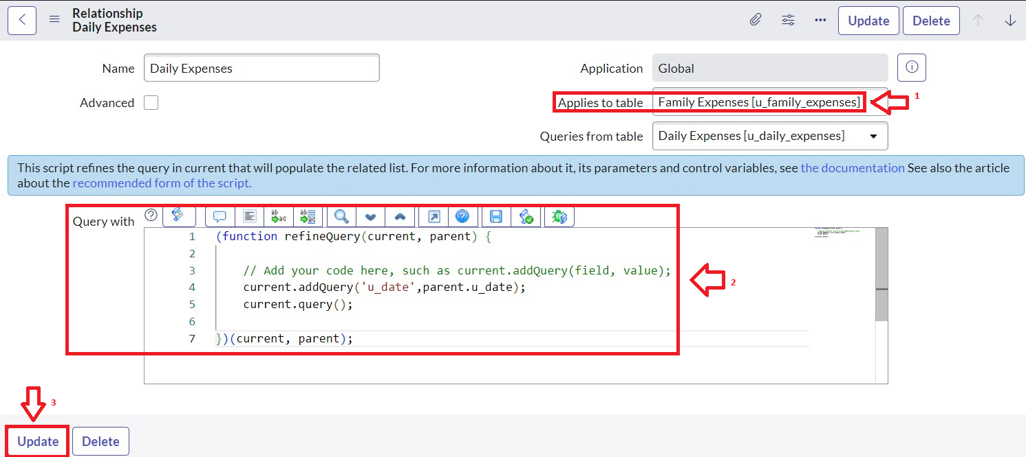Click on Update.

2.10. **Conclusion**

Thus the Family expension calculation system has been developed in the developer instance.

**Chapter : 3 – Purpose of Tables and Future Analysis**

In this project, two main tables were created in ServiceNow: **Family Expense** and **Daily Expense**. These tables serve as the foundation for storing and managing expense-related information in a structured manner. By organizing the data into these two categories, we ensure clarity, accuracy, and the ability to perform meaningful analysis later.

**3.1 Family Expense Table**

The **Family Expense Table** is designed to capture the overall financial expenditures of the family. Each record provides details such as:

* **Number** – A unique identifier for tracking each expense entry.
* **Date** – The date on which the expense was made.
* **Amount** – The total money spent in that transaction.
* **Expense Details** – A description of the expense for better understanding and categorization.

This table allows us to **track family-level expenses** and gives a summarized view of household financial patterns.

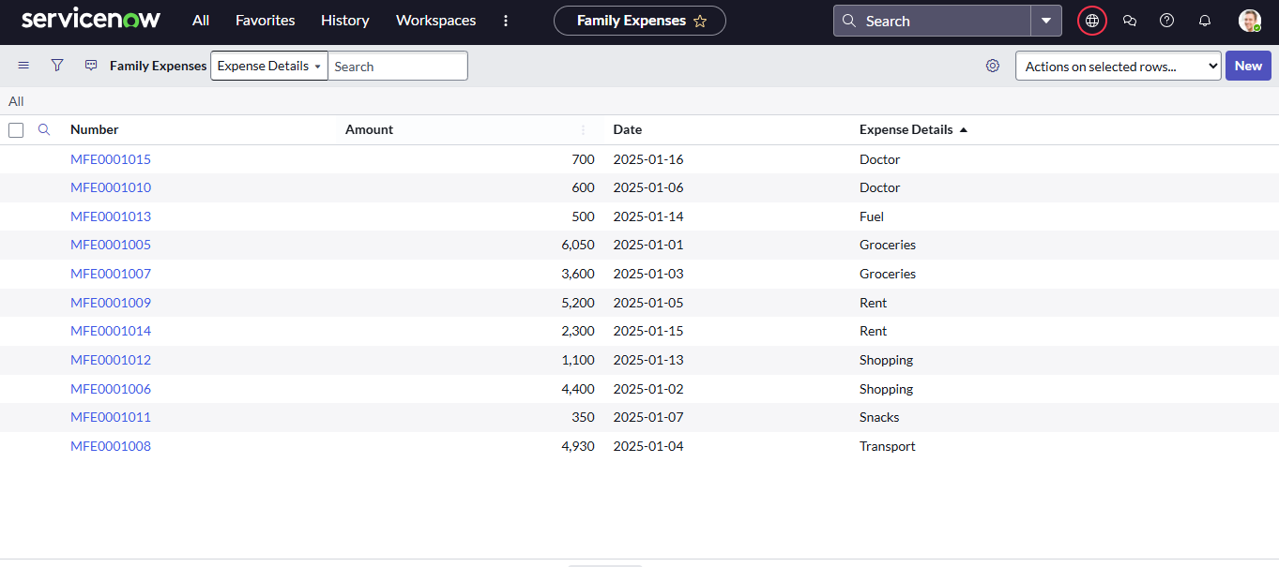

**3.2 Daily Expense Table**

The **Daily Expense Table** focuses on recording **individual expenses by each family member**. Each record provides details such as:

* **Number** – A unique identifier for the daily entry.
* **Date** – The specific day the expense occurred.
* **Expense** – The money spent by a family member.
* **Family Member Name** – Identifies which member made the expense.
* **Comments** – Additional notes or reasons for the expense.

This table allows us to capture **day-to-day spending behavior** and helps in identifying **who spends what amount on which day**.

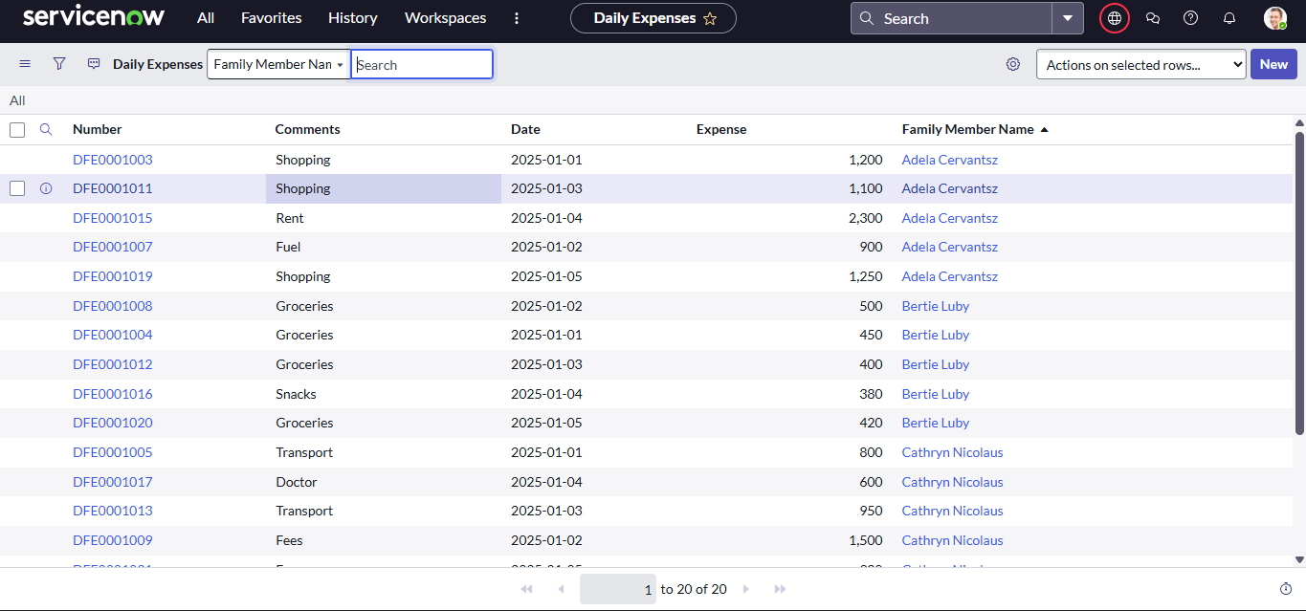

**3.3 Purpose of Creating These Tables**

The creation of these two tables serves multiple objectives:

1. **Data Organization:** Expenses are divided into two categories – overall family expenses and individual daily expenses – making records easier to manage.
2. **Accountability:** Helps identify who spends money and how much is spent collectively.
3. **Transparency:** Provides clarity in household finance by separating personal expenses from shared family expenses.
4. **Foundation for Analysis:** Structured data ensures we can perform advanced analysis like trends, comparisons, and forecasting.

**3.4 Future Analysis with the Tables**

With these tables in place, various types of **financial analysis** can be carried out to gain valuable insights:

1. **Monthly Expense Trends:** Analyze the rise and fall of expenses across different months.
2. **Family Member Contribution:** Identify which family member spends the most and compare expenses between members.
3. **Category-wise Expense Tracking:** Use the **Expense Details** column to categorize (e.g., food, travel, shopping) and see where most of the money goes.
4. **Budget Planning:** Compare daily vs. family expenses to set realistic budgets.
5. **Forecasting:** Use historical data to predict upcoming expenses and prepare for them.
6. **Savings Opportunities:** Identify unnecessary expenses and suggest cost-cutting measures.
7. **Custom Dashboards in ServiceNow:** Build reports and dashboards to visualize expenses (pie charts for category distribution, line charts for monthly trends, bar charts for member-wise expenses).

**Chapter 4: Practical Applications of Family Expense Management**

The **Family Expenses** and **Daily Expenses** tables developed in the ServiceNow platform serve more than just data storage—they offer valuable insights that help improve household budgeting and spending decisions. By organizing financial data in a structured way, this system supports detailed analysis and helps families make smarter, data-driven choices. The following use cases illustrate how the system can be applied in real-life situations:

**4.1 Monitoring Monthly Spending Trends**

The Family Expenses table can be used to total all expenses for each month, allowing families to track how their costs evolve over time.

* **Example:**  
  If a family’s total spending is ₹45,000 in January and increases to ₹52,000 in February, this ₹7,000 difference prompts them to investigate which categories (e.g., groceries, utilities, or discretionary shopping) contributed to the rise.

**4.2 Determining the Top Spender in the Household**

With entries recorded in the Daily Expenses table, it becomes easy to compare individual spending across all family members.

* **Example:**  
  Among four members—Father, Mother, Son, and Daughter—the Son’s expenses total ₹12,000, mostly on entertainment and gadgets, while others spend less than ₹7,000. This indicates he’s the biggest contributor to non-essential spending.

**4.3 Analyzing Spending by Category**

The system can classify spending into specific categories using the details entered in the Family Expenses table, enabling a breakdown by type of expense.

* **Example:**  
  The data shows that 40% of the household budget goes toward food, 25% to utility bills, and 15% to shopping. These insights can guide the family in rebalancing their budget if one area seems excessive.

**4.4 Comparing Budgeted vs. Actual Expenses**

Families often set spending limits for the month. The system helps compare these budgets with real spending data from the Family Expenses table.

* **Example:**  
  If the monthly budget is ₹50,000 but actual expenses for March total ₹55,500, this overshoot can be flagged. The detailed breakdown can help identify whether the excess was due to necessary costs or unnecessary spending.

**4.5 Finding Cost-Saving Opportunities**

The Daily Expenses records can help identify duplicated or unnecessary purchases that could be eliminated to save money.

* **Example:**  
  Two members are each paying ₹500 for the same OTT subscription. By consolidating into a single account, the family can save ₹500 every month.

**4.6 Forecasting Future Expenses**

By reviewing historical data, the system can help families estimate and plan for upcoming costs more accurately.

* **Example:**  
  If electricity bills increase by 10% every summer, the system can predict an expected spike in May and June, giving the family a chance to prepare an extra ₹2,000 in advance.

**4.7 Tracking Unexpected or Emergency Expenses**

Certain expenses may be one-time or unpredictable. These can be flagged and reviewed to build a financial buffer.

* **Example:**  
  A sudden hospital expense of ₹8,000 in April suggests the need to start an emergency fund for medical needs or similar unplanned situations.

**4.8 Visualizing Data Through Dashboards**

ServiceNow’s built-in reporting features enable the creation of clear, visual dashboards that simplify financial analysis.

* **Examples:**
  + **Pie Chart:** Shows distribution of spending across categories like Food, Travel, and Utilities.
  + **Bar Chart:** Compares individual spending among family members.
  + **Line Chart:** Illustrates the rise and fall of expenses over each month in the year.

## ****Chapter 5: Data Analysis, Challenges, and Visual Insights****

This chapter showcases how data stored in the **Family Expenses** and **Daily Expenses** tables can be used to solve real-world financial challenges. By analyzing patterns and using visual tools such as bar charts and line graphs, we gain a clearer understanding of how money is spent and where improvements can be made. We’ll walk through four common scenarios—two from each table—along with step-by-step solutions and data visualizations.

### ****5.1 Insights from the Family Expenses Table****

#### **Problem 1: Determining the Top Expense Category for January 2025**

* **Step 1:** Examine the “Expense Details” field in the Family Expenses table.
* **Step 2:** Categorize all entries (e.g., Rent, Groceries, Transport, etc.).
* **Step 3:** Calculate the total amount spent in each category.
* **Step 4:** Compare the totals to determine which category had the highest spending.

📊 **Visual Example – Bar Chart**  
(X-axis: Expense Categories, Y-axis: Amount in ₹)

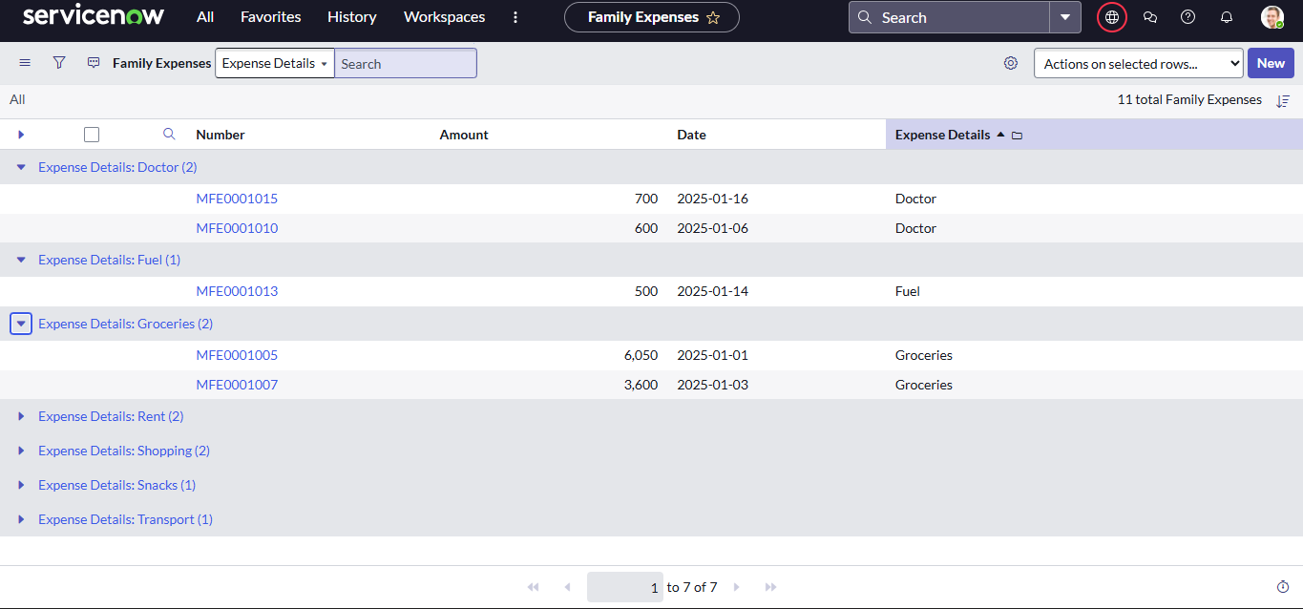

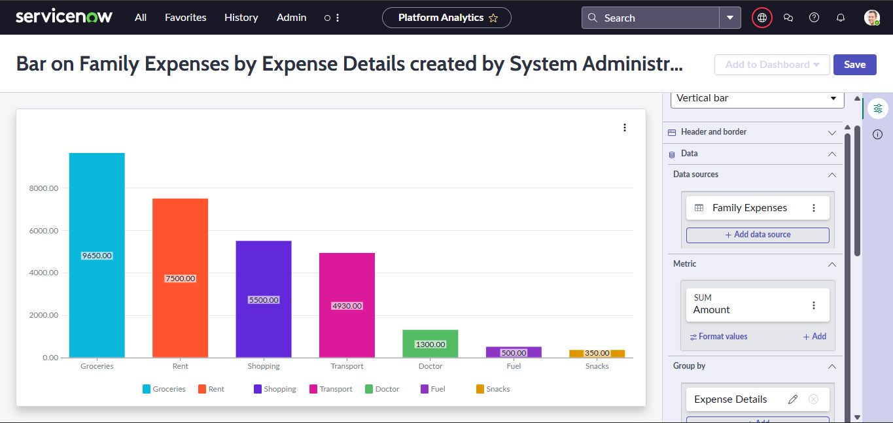

➡️ **Conclusion:** Groceries accounted for the largest share of spending in January, totaling ₹9,650.

#### **Problem 2: Evaluating Weekly Spending Trends**

* **Step 1:** Use the “Date” column to segment expenses into weekly intervals (e.g., Week 1: Jan 1–7, Week 2: Jan 8–14, Week 3: Jan 15–21).
* **Step 2:** Sum all expenses for each week.
* **Step 3:** Analyze fluctuations in weekly totals to identify peak spending periods.

📊 **Visual Example – Line Chart**  
(X-axis: Week, Y-axis: Total Weekly Spending)

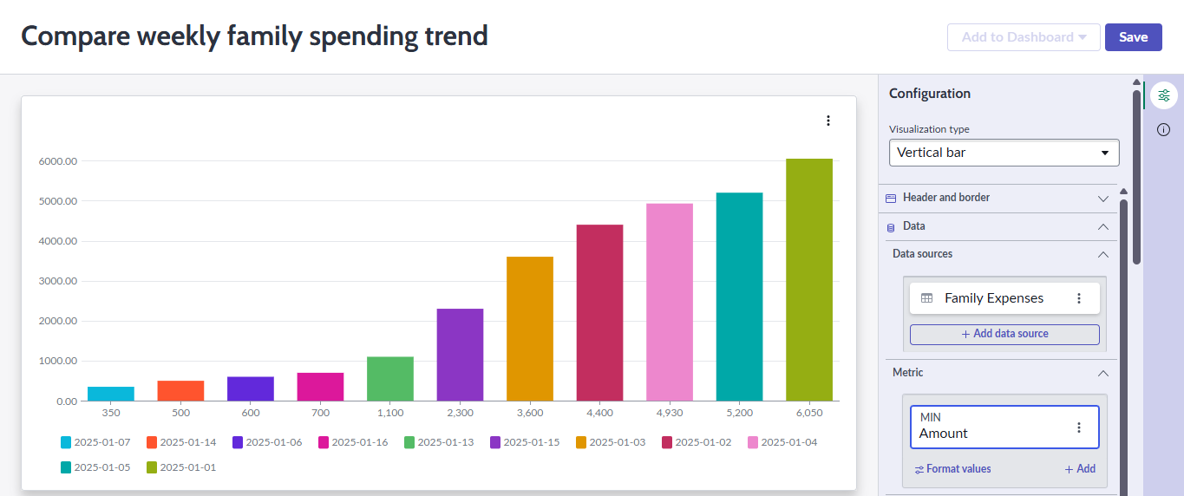

➡️ **Conclusion:** Week 1 had the highest expenditure, driven largely by recurring costs such as rent and groceries.

### ****5.2 Insights from the Daily Expenses Table****

#### **Problem 3: Identifying the Highest-Spending Family Member**

* **Step 1:** Use the “Family Member Name” column.
* **Step 2:** Group all transactions under each family member.
* **Step 3:** Sum up the expenses per person.
* **Step 4:** Compare totals to find the highest spender.

📊 **Visual Example – Bar Chart**  
(X-axis: Family Members, Y-axis: Total Spent in ₹)

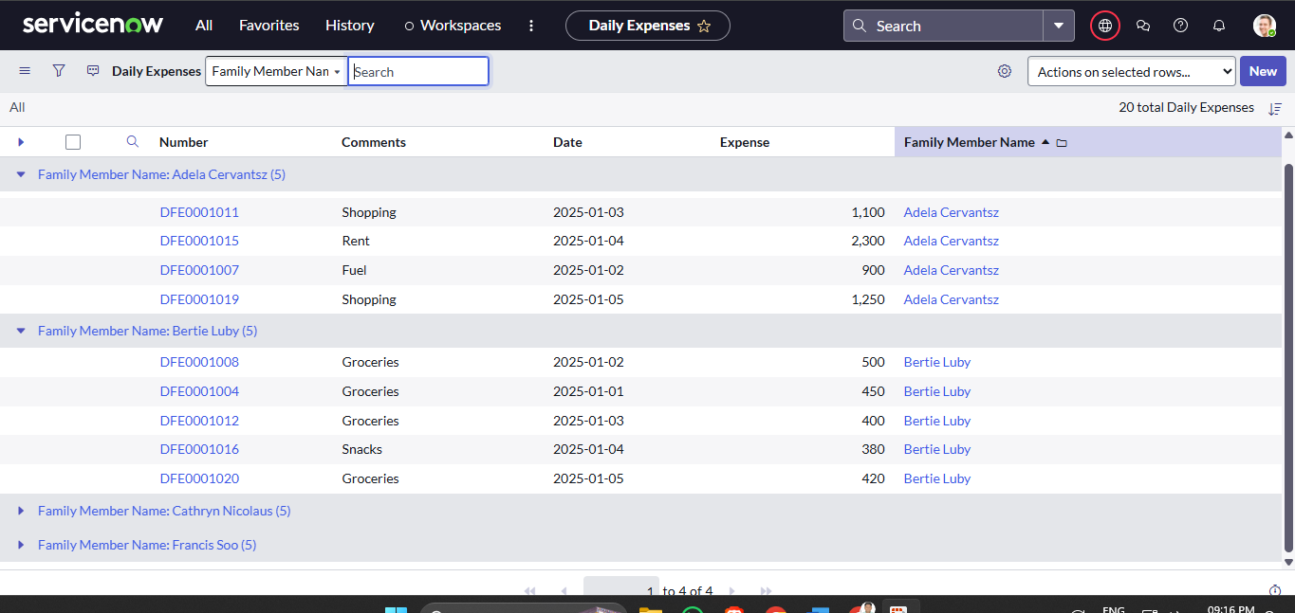

h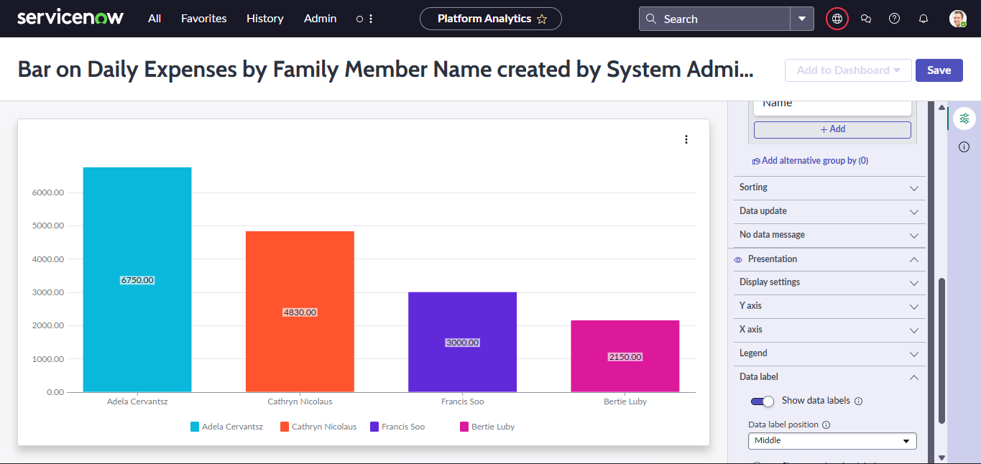

➡️ **Conclusion:** Cathryn Nicolaus had the highest spending in January, with a total of ₹5,530.

#### **Problem 4: Breaking Down Spending Types by Family Member**

* **Step 1:** Review the “Comments” column for types of spending (e.g., Fuel, Fees, Shopping, Electricity, etc.).
* **Step 2:** Categorize each family member's expenses by type.
* **Step 3:** Compare and visualize to see who spends on what.

📊 **Visualization Example:**  
A **stacked bar chart** with family members on the X-axis and expense categories stacked by value.

* Adela Cervantsz spent mostly on Shopping and Rent.
* Bertie Luby spent mostly on Groceries.
* Cathryn Nicolaus spent on Transport, Doctor, and Fees.
* Francis Soo spent small amounts on Snacks, Electricity, Fuel.

➡️ This analysis helps understand **individual spending behavior**.

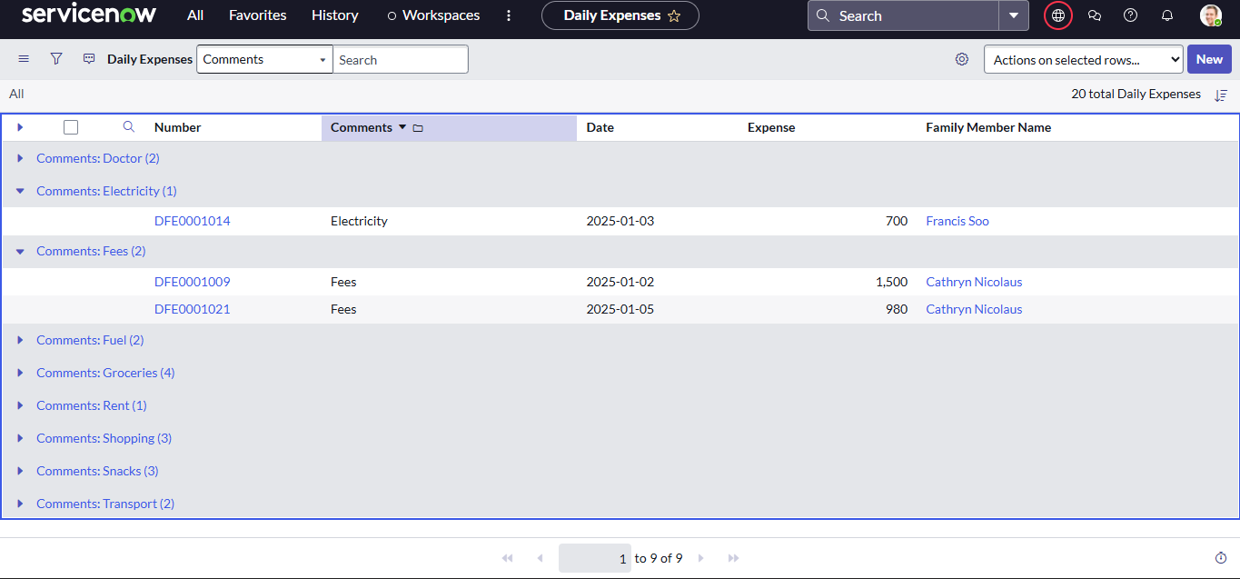

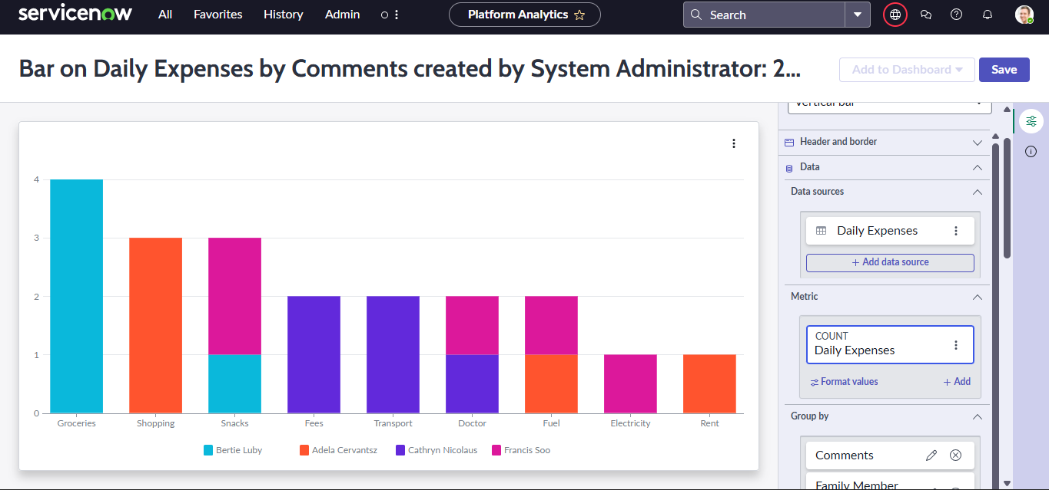

**Conclusion**

The project **Family Expense Management using ServiceNow** successfully demonstrated how digital platforms can be used to record, track, and analyze both **daily expenses** and **overall family expenses**. By creating two structured tables—**Family Expenses** and **Daily Expenses**—we established a clear data model that allows for systematic recording of every transaction, along with details such as date, amount, category, and the family member responsible.

Through analysis, we were able to:

* Identify the **highest spending categories** (e.g., groceries, shopping, rent).
* Track **weekly and monthly spending patterns** to understand fluctuations.
* Compare the **spending behavior of individual family members**.
* Categorize expenses (e.g., fuel, transport, snacks, fees) to highlight priority areas.

Using **visualizations such as bar charts and line graphs**, the data became more understandable and actionable. These insights make it easier to answer real-life questions like *“Which member spends the most?”, “What category consumes the largest budget?”, and “How do expenses change over weeks?”*

However, challenges such as grouping by **weeks or months** required either calculated fields or external tools like Excel/Pandas for deeper aggregation. This showed that while ServiceNow is effective for tracking and reporting, integration with external analysis tools can enhance decision-making.

Overall, the project proves that **ServiceNow can serve as a powerful tool for personal finance tracking**, helping families monitor expenses, avoid overspending, and plan budgets more effectively.

**Thank you for Reading**